|  |  |
| --- | --- |
| **Assignment Date** | 25 September 2022 |
| **Student Name** | Mirun Kannan V |
| **Student Roll Number** | 731619104033 |
| **Maximum Marks** | 2 Marks |

# Solution:

1. **LOCATION COLOURED BY SALES?**
2. **INVERTORY STOCK BY WARE HOUSE? SOLUTION**

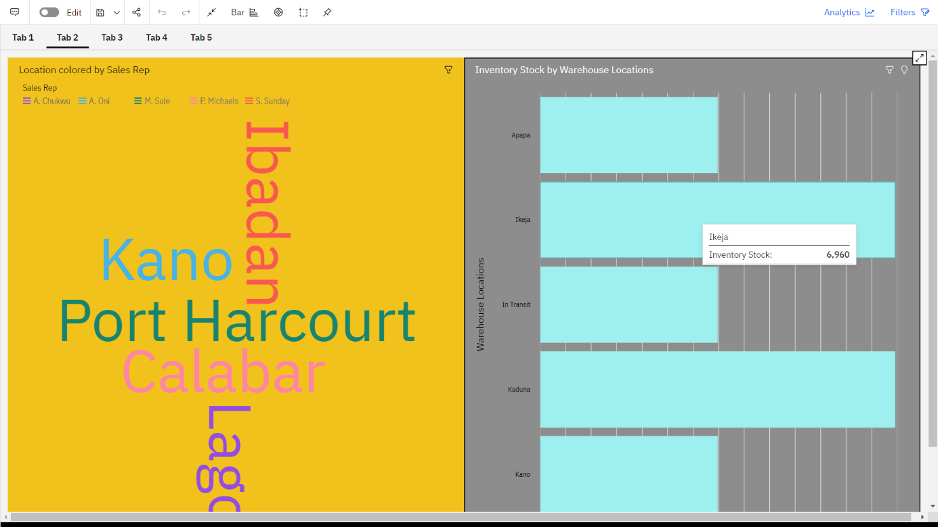

4)SUPPLIER SIZED BY INVENTORY STOCK? SOLUTION

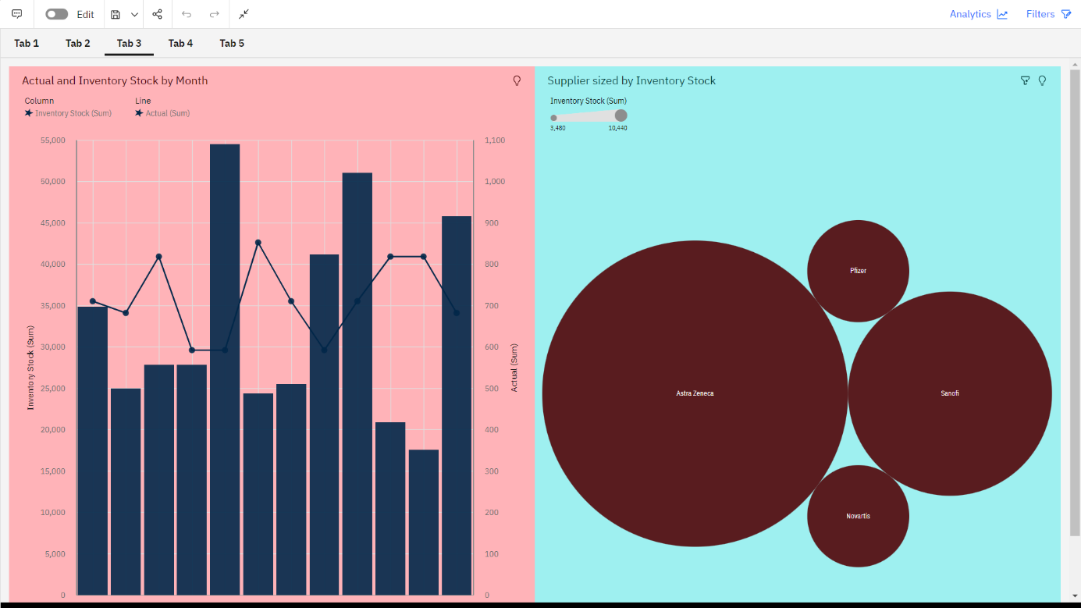

6)SALES BY CUSTOMER? SOLUTION

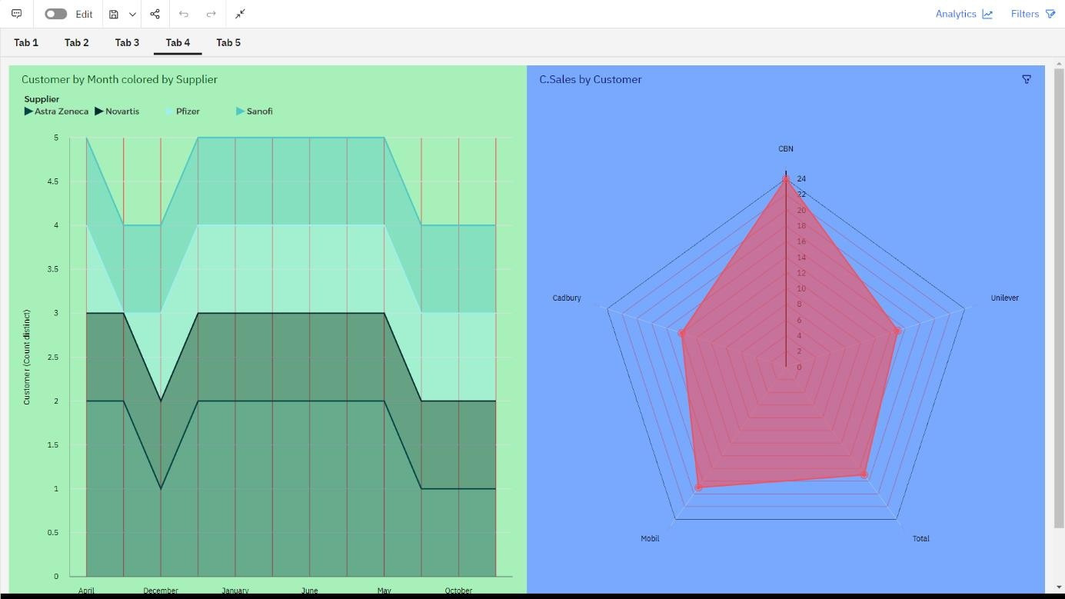

8)TARGET FOR SALES REP? SOLUTION

